Data Analytics in Finance - Project

import matplotlib.pyplot as plt  
import pandas as pd  
import seaborn as sns

df = (  
 pd.read_csv(filepath_or_buffer='histretSP.csv', index_col='Year')  
 .mul(100)  
 .agg(['mean', 'std'])  
 .transpose()  
)  
  
sns.regplot(  
 data=df,  
 y='mean',  
 x='std'  
)  
  
for t, (x, y) in df[['std', 'mean']].iterrows():  
 plt.annotate(text=t, xy=(x, y))  
  
plt.xlabel('Volatilty of Annual Returns (%)')  
plt.ylabel('Mean of Annual Returns (%')  
plt.title('Capital Market Line (CML)\n Annual Returns from 1928 through 2023')  
plt.show()

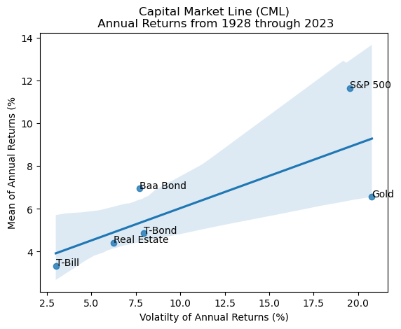

data_path = 'histretSP.csv'  
df = pd.read_csv(data_path, index_col='Year')  
all_equity_returns = df['S&P 500']  
  
mean_return = all_equity_returns.mean()  
risk = all_equity_returns.std()  
  
risk_free_rate = 0.03  
sharpe_ratio = (mean_return - risk_free_rate) / risk  
  
print("All-Equity Portfolio:")  
print(f"Mean Return: {mean_return:.2%}")  
print(f"Risk (Standard Deviation): {risk:.2%}")  
print(f"Sharpe Ratio: {sharpe_ratio:.2f}")  
  
plt.plot(all_equity_returns.index, all_equity_returns, label='S&P 500')  
plt.xlabel('Year')  
plt.ylabel('Return (%)')  
plt.title('All-Equity Portfolio (S&P 500) - Annual Returns')  
plt.grid(True)  
plt.legend()  
plt.show()

All-Equity Portfolio:  
Mean Return: 11.66%  
Risk (Standard Deviation): 19.55%  
Sharpe Ratio: 0.44

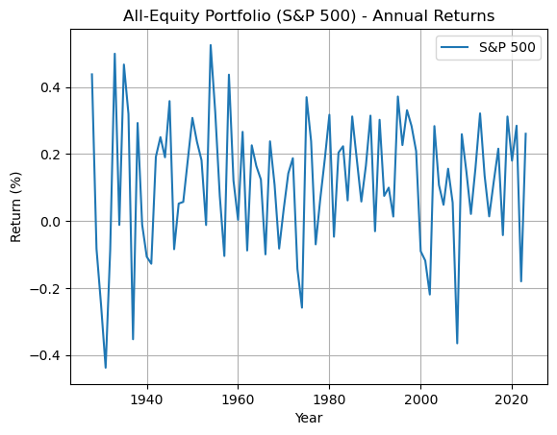

### Pros and Cons of All-Equity Portfolio

**Pros:**

▪ Highest Returns: Investing in an all-equity portfolio provides the highest returns over the long term. The average annual return of 11.66% showcases the potential for significant growth in wealth. Equities have consistently outperformed other asset classes over extended periods, making them an attractive option for investors aiming for substantial returns.

▪ Simple Strategy: An all-equity portfolio simplifies decision-making for investors. With this strategy, the focus is on growth, making it ideal for those who prefer a straightforward approach to wealth accumulation. By eliminating the need to consider various asset classes or complex investment strategies, investors can maintain clarity and confidence in their investment decisions.

▪ Liquidity: Equities are highly liquid assets, meaning they can be easily bought or sold in the market without significantly impacting their prices. This liquidity provides investors with the flexibility to adjust their investment holdings based on changing market conditions, personal financial goals, or unforeseen circumstances. It also enables investors to quickly capitalize on investment opportunities or exit positions when necessary.

**Cons:**

▪ Highest Volatility: Equities are prone to significant fluctuations in value, as indicated by a standard deviation of 19.55%. These fluctuations can be influenced by various factors such as economic conditions, company performance, and market sentiment. While this volatility can present opportunities for high returns, it also increases the risk of sudden and substantial losses.

▪ Economic Uncertainty: Equities are sensitive to economic conditions and changes in government policies, both domestically and internationally. Economic downturns, recessions, or geopolitical events can adversely affect stock prices, leading to losses for investors. This uncertainty adds another layer of risk to an all-equity portfolio, as there’s no guaranteed protection against economic shocks.

▪ No Fixed Income Component: Unlike balanced portfolios that include bonds or other fixed-income securities, an all-equity portfolio lacks a fixed-income component. Fixed-income securities typically provide steady income and act as a buffer against market downturns. Without this stabilizing element, investors in an all-equity portfolio may experience greater volatility and risk, especially during periods of market turbulence.

df.columns = df.columns.str.strip().str.title()  
  
portfolio_60_40_returns = 0.60 * df['S&P 500'] + 0.40 * df['T-Bond']  
  
mean_return_60_40 = portfolio_60_40_returns.mean()  
risk_60_40 = portfolio_60_40_returns.std()  
  
risk_free_rate = 0.03  
sharpe_ratio_60_40 = (mean_return_60_40 - risk_free_rate) / risk_60_40  
  
print("Traditional 60/40 Portfolio:")  
print(f"Mean Return: {mean_return_60_40:.2%}")  
print(f"Risk (Standard Deviation): {risk_60_40:.2%}")  
print(f"Sharpe Ratio: {sharpe_ratio_60_40:.2f}")  
  
plt.plot(portfolio_60_40_returns.index, portfolio_60_40_returns, label='60/40 Portfolio', linestyle='-', color='b')  
plt.title('Traditional 60/40 Portfolio - Annual Returns')  
plt.xlabel('Year')  
plt.ylabel('Return (%)')  
plt.grid(True)  
plt.legend()  
plt.show()

Traditional 60/40 Portfolio:  
Mean Return: 8.94%  
Risk (Standard Deviation): 12.22%  
Sharpe Ratio: 0.49

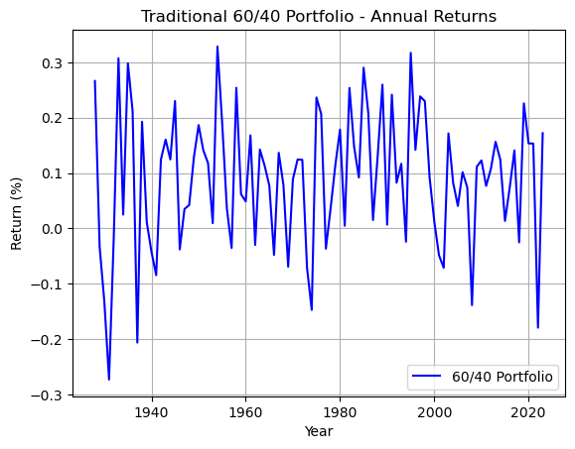

### Pros and Cons of Traditional 60/40 Portfolio

**Pros:**

▪ Balanced Approach: A Traditional 60/40 Portfolio strikes a balance between growth and stability by allocating 60% to equities and 40% to bonds. This strategic mix aims to capture the potential for capital appreciation from stocks while leveraging the stability and income-generating qualities of bonds. By diversifying across asset classes, investors seek to achieve a smoother overall investment experience, mitigating the extreme highs and lows associated with individual asset classes.

▪ Reduced Volatility: One of the key advantages of including bonds in a portfolio is their ability to dampen volatility, particularly during periods of market turbulence. While equities can experience significant fluctuations in value, bonds often exhibit more stable price movements. Consequently, the inclusion of bonds can help cushion the impact of equity market downturns, reducing the overall portfolio’s volatility and providing investors with a more predictable investment journey. This is evident in the comparison between the risk of an all-equity portfolio, which stood at 19.55%, and that of a traditional 60/40 Portfolio, where the risk was reduced to 12.22%. This significant reduction in risk highlights the effectiveness of the 60/40 portfolio in managing volatility and preserving capital.

▪ Income Generation: Bonds are renowned for their income-generating potential, as they typically offer regular interest payments to investors. By allocating a portion of the portfolio to bonds, investors can enjoy a consistent stream of income, which can be particularly beneficial during retirement or other periods when steady cash flow is desired. This income component adds an extra layer of financial stability and can contribute to meeting short-term financial needs without having to rely solely on selling equities.

**Cons:**

▪ Moderate Returns: A 60/40 portfolio typically aims for a balance between growth and stability. While this can provide steadier returns over time, especially during market downturns, it may not achieve the same level of returns as an all-equity portfolio, which carries higher risk but also the potential for higher rewards. Investors seeking maximum growth might find the returns from a 60/40 portfolio to be moderate in comparison. The mean return in a traditional 60/40 portfolio was 8.94%, while that in an all-equity portfolio was 11.66%. This numerical comparison underscores the tendency of the 60/40 portfolio to deliver lower returns relative to an all-equity allocation strategy.

▪ Interest Rate Risk: Bonds are sensitive to changes in interest rates. When interest rates rise, the value of existing bonds typically falls, because newer bonds offer higher yields. In a 60/40 portfolio, the bond component could suffer losses if interest rates increase, impacting the overall portfolio value. This risk is particularly relevant in environments where interest rates are expected to trend upward.

▪ Limited Growth: With 40% of the portfolio allocated to bonds, there’s a cap on the growth potential compared to a more aggressive equity-heavy portfolio. Bonds are generally considered safer investments, offering steady income and stability, but they typically don’t deliver the same level of long-term growth as equities. Therefore, the growth potential of a 60/40 portfolio might be constrained by the significant allocation to bonds.

df.columns = df.columns.str.strip().str.title()  
  
portfolio_permanent_returns = (  
 0.25 * df['S&P 500'] +  
 0.25 * df['T-Bond'] +  
 0.25 * df['T-Bill'] +  
 0.25 * df['Gold']  
)  
  
mean_return_permanent = portfolio_permanent_returns.mean()  
risk_permanent = portfolio_permanent_returns.std()  
  
risk_free_rate = 0.03  
sharpe_ratio_permanent = (mean_return_permanent - risk_free_rate) / risk_permanent  
  
print("Harry Browne's Permanent Portfolio:")  
print(f"Mean Return: {mean_return_permanent:.2%}")  
print(f"Risk (Standard Deviation): {risk_permanent:.2%}")  
print(f"Sharpe Ratio: {sharpe_ratio_permanent:.2f}")  
  
plt.plot(portfolio_permanent_returns.index, portfolio_permanent_returns, label='Permanent Portfolio', color='orange')  
plt.title("Harry Browne's Permanent Portfolio - Annual Returns")  
plt.xlabel('Year')  
plt.ylabel('Return (%)')  
plt.grid(True)  
plt.legend()  
plt.show()

Harry Browne's Permanent Portfolio:  
Mean Return: 6.60%  
Risk (Standard Deviation): 7.31%  
Sharpe Ratio: 0.49

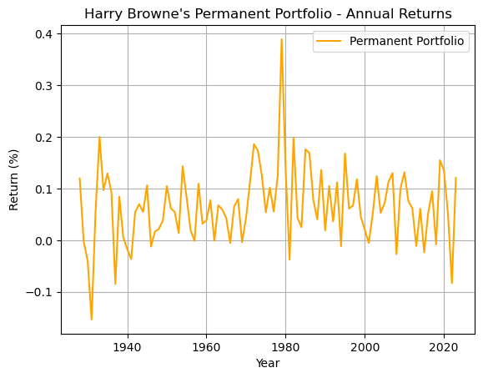

### Pros and Cons of Hary Browne’s Permanent Portfolio

**Pros:**

▪ Diversification: The Permanent Portfolio allocates investment capital across four asset classes: equities, long-term treasury bonds, treasury bills (cash), and gold. This aims to reduce risk by spreading it out across asset classes that may perform differently under various economic conditions. For example, when stocks fall during a recession, bonds may rise as investors seek safety. Similarly, gold may act as a hedge against inflation, while cash provides stability and liquidity.

▪ Stability: The Permanent Portfolio is designed to provide a balance between growth potential (equities) and capital preservation (bonds, cash, gold). This may lead to more moderate returns compared to other investment strategies. However, it also aims for lower volatility, with a standard deviation of 7.31% which means the portfolio’s value should fluctuate less dramatically over time. This can be appealing to risk-averse investors or those nearing retirement who prioritize capital protection.

▪ Simple to Manage: The Permanent Portfolio’s equal weighting (25% each) of asset classes minimizes the need for frequent adjustments. This can be appealing to investors who prefer a buy-and-hold approach or who lack the time or expertise to actively manage their portfolios. With the Permanent Portfolio, you set it up and rebalance periodically to maintain the 25% allocation in each asset class, requiring less ongoing monitoring compared to actively managed funds.

**Cons:**

▪ Lowest Returns: The Permanent Portfolio, with its fixed allocation across four asset classes, yields the lowest returns (6.60%) compared to other investment strategies. This is primarily because it maintains a significant portion of its portfolio in other assets which typically don’t experience the same level of growth as equities during periods of economic expansion. Therefore, while it offers stability and security, it may not capture the full upside potential of the market.

▪ Fixed Allocation: The portfolio’s rigid allocation strategy can be both a strength and a weakness. While it provides a clear and simple investment approach, it lacks the flexibility to adapt to changing market conditions. For instance, if certain asset classes are experiencing significant growth opportunities while others are underperforming, the portfolio’s fixed allocation may hinder its ability to capitalize on those opportunities or mitigate risks effectively.

▪ Dependency on Asset Correlation: The effectiveness of the Permanent Portfolio is heavily reliant on the historical correlations between its constituent assets. If these correlations shift unexpectedly, the portfolio’s performance may suffer. For example, if gold, traditionally seen as a hedge against inflation, fails to perform as expected during periods of economic turmoil, it could negatively impact the overall portfolio returns. Similarly, if bonds and equities become more correlated during market stress, the diversification benefits of the portfolio may diminish.

df.columns = df.columns.str.strip().str.title()  
portfolio_all_seasons_returns = (  
 0.30 * df['S&P 500'] +  
 0.40 * df['T-Bond'] +  
 0.15 * df['T-Bond'] +  
 0.075 * df['Gold'] +   
 0.075 * df['Gold']  
)  
  
mean_return_all_seasons = portfolio_all_seasons_returns.mean()  
risk_all_seasons = portfolio_all_seasons_returns.std()  
  
risk_free_rate = 0.03  
sharpe_ratio_all_seasons = (mean_return_all_seasons - risk_free_rate) / risk_all_seasons  
  
print("Ray Dalio's All-Seasons Portfolio:")  
print(f"Mean Return: {mean_return_all_seasons:.2%}")  
print(f"Risk (Standard Deviation): {risk_all_seasons:.2%}")  
print(f"Sharpe Ratio: {sharpe_ratio_all_seasons:.2f}")  
  
plt.plot(portfolio_all_seasons_returns.index, portfolio_all_seasons_returns, label="All-Seasons Portfolio", color='green')  
plt.title("Ray Dalio's All-Seasons Portfolio - Annual Returns")  
plt.xlabel('Year')  
plt.ylabel('Return (%)')  
plt.grid(True)  
plt.legend()  
plt.show()

Ray Dalio's All-Seasons Portfolio:  
Mean Return: 7.15%  
Risk (Standard Deviation): 7.83%  
Sharpe Ratio: 0.53

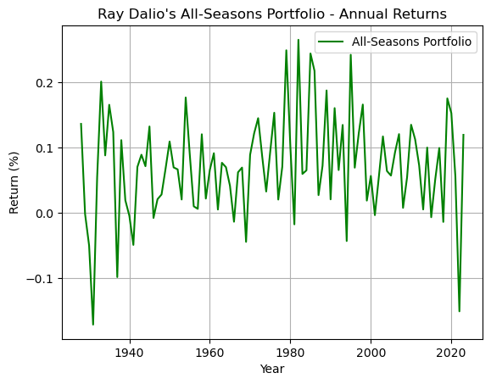

### Pros and Cons of Ray Dalio’s All Seasons portfolio

**Pros:**

▪ Enhanced Yield Stability: Ray Dalio’s All Seasons Portfolio incorporates a broader range of fixed-income securities compared to the Permanent Portfolio. By allocating 40% to long-term Treasury bonds and 15% to intermediate Treasury bonds, this portfolio aims to capitalize on the yield potential of these bonds while maintaining a relatively stable income stream. Long-term Treasury bonds typically offer higher yields compared to shorter-term bonds, while intermediate bonds strike a balance between yield and interest rate risk. This diversified bond allocation can provide investors with a more consistent and predictable income stream, which may be particularly attractive for those seeking steady cash flows, such as retirees or income-focused investors. Additionally, the All-Seasons Portfolio historically has a mean return of 7.15%, outperforming the Permanent Portfolio’s mean return of 6.60%. This suggests that while both portfolios prioritize stability, the All-Seasons Portfolio may offer slightly higher returns over the long term, potentially enhancing overall portfolio growth.

▪ Inflation Protection through Commodities: Unlike the Permanent Portfolio, Ray Dalio’s All Seasons Portfolio includes an allocation to commodities. Commodities have historically demonstrated a low correlation with traditional asset classes like stocks and bonds. By including commodities in the portfolio, investors gain exposure to an asset class that tends to perform well during periods of inflation or supply shocks. This can act as a hedge against rising prices and help preserve the purchasing power of the portfolio over the long term. Additionally, commodities can provide diversification benefits by exhibiting different return patterns compared to equities and fixed-income securities, thus enhancing the overall risk-adjusted returns of the portfolio.

▪ Dynamic Asset Allocation: Ray Dalio’s All Seasons Portfolio incorporates a higher allocation to equities (30%) compared to the Permanent Portfolio. This allocation reflects Dalio’s belief in the long-term growth potential of equities as a wealth-building asset class. However, the portfolio also maintains a significant allocation to fixed-income securities and alternative assets like gold and commodities, which tend to be less volatile. By dynamically balancing between growth-oriented assets (equities) and defensive assets (bonds, gold, commodities), the portfolio seeks to achieve consistent returns across various market environments. This dynamic asset allocation strategy can help mitigate downside risk during periods of market volatility while still capturing upside potential during periods of economic expansion, making it suitable for investors with a balanced risk tolerance.

**Cons:**

▪ Limited Exposure to Growth Assets: Unlike some other portfolios, such as those with higher equity allocations, the All-Seasons Portfolio may offer limited exposure to high-growth assets. With only 30% allocated to equities, there may be missed opportunities to capture the full upside potential of the market during periods of economic expansion. This could result in comparatively lower returns over the long term, especially in bull markets. Based on historical data, the mean return for the All-Seasons Portfolio is 7.15%, which is lower compared to portfolios with higher equity allocations. This lower mean return may deter investors seeking higher growth potential, especially in environments conducive to equity market outperformance.

▪ Complexity and Rebalancing Challenges: The All-Seasons Portfolio’s allocation across multiple asset classes, can introduce complexity and increase the need for frequent rebalancing. Managing the portfolio to maintain its desired asset allocation can be challenging, especially for individual investors without access to sophisticated tools or professional assistance. This complexity may deter some investors who prefer simpler investment strategies.

▪ Vulnerability to Inflation and Interest Rate Risks: While the portfolio includes allocations to inflation-hedging assets like commodities and gold, its heavy reliance on bonds, particularly long-term treasury bonds, exposes it to inflation and interest rate risks. In environments of rising inflation or increasing interest rates, bond prices tend to decline, negatively impacting the portfolio’s overall performance. This vulnerability to inflation and interest rate risks could lead to suboptimal returns or increased volatility, especially during economic environments characterized by monetary policy changes.

df.columns = df.columns.str.strip().str.title()  
custom_portfolio_weights = {  
 'S&P 500': 0.30,  
 'T-Bond': 0.40,  
 'Real Estate': 0.20,  
 'Gold': 0.10  
}  
  
custom_portfolio_returns = (  
 sum(df[asset] * weight for asset, weight in custom_portfolio_weights.items())  
)  
  
mean_return_custom = custom_portfolio_returns.mean()  
risk_custom = custom_portfolio_returns.std()  
  
risk_free_rate = 0.03  
sharpe_ratio_custom = (mean_return_custom - risk_free_rate) / risk_custom  
  
print("Custom Portfolio:")  
print(f"Mean Return: {mean_return_custom:.2%}")  
print(f"Risk (Standard Deviation): {risk_custom:.2%}")  
print(f"Sharpe Ratio: {sharpe_ratio_custom:.2f}")  
  
plt.plot(custom_portfolio_returns.index, custom_portfolio_returns, label="Custom Portfolio", color='purple')  
plt.title("Custom Portfolio - Annual Returns")  
plt.xlabel('Year')  
plt.ylabel('Return (%)')  
plt.grid(True)  
plt.legend()  
plt.show()

Custom Portfolio:  
Mean Return: 6.98%  
Risk (Standard Deviation): 7.15%  
Sharpe Ratio: 0.56

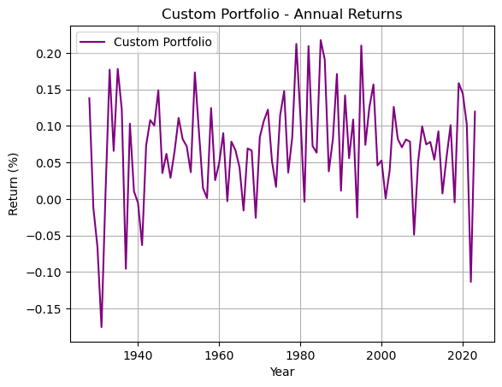

### Pros and Cons of Custom Portfolio

**Pros:**

▪ Tailored Allocation: By investing in a Custom Portfolio with a 30% allocation to equity, 40% to Treasury bonds, 20% to real estate, and 10% to gold, investors can achieve a balanced allocation that aligns with their unique risk and return goals. The allocation is carefully crafted to optimize returns while managing risk effectively. This allocation strategy aims to strike a balance between asset classes, leveraging the historical performance of each component to achieve an optimal risk-return profile. The resulting return of 6.98% coupled with the least risk of 7.15% underscores the effectiveness of this tailored approach in achieving consistent returns with reduced volatility.

▪ Flexibility: The Custom Portfolio offers investors the flexibility to tailor their investments according to their specific preferences and financial objectives. Whether an investor seeks income generation, capital preservation, or growth, this portfolio can be adjusted accordingly. With the ability to customize asset allocation percentages, investors can fine-tune their portfolios to reflect their risk tolerance, investment horizon, and market outlook.

▪ Incorporates Investor Preferences: The Custom Portfolio allows investors to integrate their personal beliefs or interests into their investment strategy. Whether prioritizing sustainability, ethical investing, or thematic exposure, this portfolio can accommodate various preferences. By incorporating asset classes such as gold and real estate alongside equities and Treasury bonds, investors can diversify their portfolios across different sectors and industries, aligning with their values or areas of interest. This approach not only enhances portfolio resilience but also enriches the investment experience.

**Cons:**

▪ Complexity: Creating a custom portfolio entails a thorough understanding of various asset classes, their historical performance, risk factors, and correlations. Investors need to research and analyze each asset class to determine its suitability for their portfolio based on factors such as investment goals, risk tolerance, and time horizon. Moreover, maintaining a balanced allocation requires ongoing monitoring and adjustments as market conditions change. This complexity can be daunting for inexperienced investors or those with limited time to devote to managing their investments.

▪ Higher Maintenance: Unlike a standardized portfolio or fund, a custom portfolio requires regular maintenance to ensure that the asset allocation stays within desired ranges. Market fluctuations can cause the value of different asset classes to deviate from their target weights, necessitating periodic rebalancing. Rebalancing involves selling assets that have appreciated beyond their target allocation and buying assets that have underperformed to restore the desired balance. This process can incur transaction costs and tax implications, adding to the overall maintenance burden

▪ Potential for Overfitting: Tailoring a portfolio to specific preferences or beliefs can lead to overfitting, where the portfolio becomes too narrowly focused on certain assets or strategies. This overemphasis can increase the portfolio’s sensitivity to particular market conditions or events, amplifying both upside potential and downside risk. Additionally, custom portfolios may incorporate complex investment strategies or niche assets that lack broad diversification, exposing investors to idiosyncratic risks. As a result, the portfolio’s performance may become overly reliant on the success of a few selected assets, potentially undermining its long-term stability and resilience.

portfolio_weights = {  
 'All-Equity': {'S&P 500': 1.0},  
 '60/40': {'S&P 500': 0.60, 'T-Bond': 0.40},  
 'Permanent': {'S&P 500': 0.25, 'T-Bond': 0.25, 'T-Bill': 0.25, 'Gold': 0.25},  
 'All-Seasons': {  
 'S&P 500': 0.30,   
 'T-Bond': 0.40,   
 'T-Bond': 0.15,   
 'Gold': 0.075,   
 'Gold': 0.075  
 },  
 'Custom': {'S&P 500': 0.30, 'T-Bond': 0.40, 'Real Estate': 0.20, 'Gold': 0.10}  
}  
portfolio_returns = {}  
portfolio_risks = {}  
  
for portfolio_name, weights in portfolio_weights.items():  
 portfolio_returns[portfolio_name] = sum(df[asset] * weight for asset, weight in weights.items()).mean()  
 portfolio_risks[portfolio_name] = sum(df[asset] * weight for asset, weight in weights.items()).std()  
  
risk_free_rate = 0.03  
portfolio_sharpe_ratios = {  
 portfolio_name: (portfolio_returns[portfolio_name] - risk_free_rate) / portfolio_risks[portfolio_name]  
 for portfolio_name in portfolio_weights.keys()  
}  
  
# Applying `max()`  
if not portfolio_sharpe_ratios:  
 raise ValueError("Sharpe ratio calculation resulted in an empty dictionary.")  
best_portfolio = max(portfolio_sharpe_ratios, key=portfolio_sharpe_ratios.get)  
  
print(f"The Best portfolio according to Sharpe ratio is: {best_portfolio} with a Sharpe ratio of {portfolio_sharpe_ratios[best_portfolio]:.2f}")

The Best portfolio according to Sharpe ratio is: Custom with a Sharpe ratio of 0.56

The Custom Portfolio stands out as the optimal choice for risk-averse investors. Here’s why:

▪ Moderate Returns: The Custom Portfolio’s strategy of allocating 30% to equity, 40% to Treasury Bonds, 20% to Real Estate, and 10% to Gold strikes a balance between growth and stability. While it may not offer the highest returns compared to other portfolios, it provides a respectable average annual return of 6.98%. This moderate return is attractive for risk-averse investors who prioritize wealth preservation and steady growth over high volatility.

▪ Lower Risk: One of the most appealing aspects of the Custom Portfolio is its relatively low-risk profile. With a standard deviation of 7.15%, it demonstrates the lowest volatility compared to other portfolios. This reduced volatility helps shield investors from sudden and significant fluctuations in portfolio value, providing a smoother investment experience and greater peace of mind, especially during turbulent market conditions.

▪ Optimal Sharpe Ratio: The Sharpe ratio is a key metric for evaluating the risk-adjusted return of an investment portfolio. A higher Sharpe ratio indicates better risk-adjusted performance. The Custom Portfolio’s Sharpe ratio of 0.56 underscores its effectiveness in generating returns relative to the level of risk undertaken. This metric reassures risk-averse investors that they are being adequately compensated for the level of risk they are exposed to, making it an appealing choice for those seeking a balanced risk-return profile.

### Limitations of the Analysis

▪ Historical Data Reliance: Relying solely on historical data can be limiting because past performance doesn’t always guarantee future results. Markets are subject to change due to various factors such as economic shifts, technological advancements, regulatory changes, and geopolitical events. What worked in the past may not necessarily work in the future, and failing to account for evolving market conditions can lead to inaccurate predictions and investment decisions.

▪ Assumption of Rationality: Traditional financial analysis often assumes that investors act rationally, meaning they consistently make decisions that maximize their utility or wealth. However, human behavior is complex and influenced by emotions, biases, and cognitive limitations. Investors may exhibit irrational behaviors such as herd mentality, overconfidence, loss aversion, and anchoring, which can lead to market inefficiencies and deviations from rationality. Ignoring these behavioral aspects can result in flawed analysis and investment strategies.

▪ Market Unpredictability: Despite efforts to analyze and predict market trends, the financial markets are inherently unpredictable. External factors such as natural disasters, political turmoil, terrorist attacks, or pandemics can significantly impact market dynamics and asset prices in ways that are difficult to anticipate. Moreover, the interconnectedness of global markets means that events in one part of the world can have ripple effects across other regions, amplifying the level of unpredictability.

### Analysis: Choosing the Optimal Portfolio Allocation

After evaluating five distinct investment portfolios and considering the average risk aversion and the goal of maximizing mean-variance efficiency, it becomes evident that the Traditional 60/40 Portfolio stands out as the most compelling choice for investing the entire net worth. Here’s a breakdown of the analysis:

Among the options, the Traditional 60/40 Portfolio offers a mean return closest to the average return and risk of all five portfolios, with returns of 8.94% and risk of 12.22%, aligning well with the desired balance of risk and reward. Additionally, its Sharpe ratio of 0.49 reflects the average Sharpe ratio of all five portfolios, emphasizing its ability to generate returns in line with the level of risk undertaken. By allocating 60% to equities and 40% to bonds, this portfolio strikes a balance between growth and stability, catering to the average risk aversion. The inclusion of bonds helps dampen portfolio volatility, offering a smoother investment experience compared to an all-equity portfolio. Bonds also contribute to steady income generation, adding a layer of financial stability and meeting short-term cash flow needs.

### Conclusion

Considering the average risk aversion and the objective of maximizing mean-variance efficiency, the Traditional 60/40 Portfolio emerges as the optimal choice. It offers a balanced mix of growth potential and stability, aligning closely with the average returns, risk, and Sharpe ratio of all evaluated portfolios. Therefore, allocating the entire net worth to the Traditional 60/40 Portfolio presents a prudent investment strategy for achieving the financial goals while managing risk.